TLC Weekly: Sunday, January 9 to Sunday, January 16
Sunday, January 9 9am Youth-led Communion Worship – Food Shelf Sunday
Epiphany Sunday 10am Coffee Fellowship
10:15am Education Hour
Monday, January 10 9am Lutheran Men in Mission Bible Study
Wednesday, January 12 9am Do-Day Ladies
10am Prairie View Communion Service
1:30pm Glory Circle
2pm O’Brien Court Communion Service
6:30pm Chancel Choir
6:30pm Youth Group (gr. 7-12)
Friday, January 14 8am Breakfast and Bible (10-12 gr.) @ Amy Munson’s
Sunday, January 16 9am Worship
2 Epiphany 10am Coffee Fellowship
10:15am Education Hour
2pm “Celebration of Song” – Annual Community Event here at Tracy Lutheran

The Radio Broadcast (KMHL 1400AM – or – 101.7FM) for this Sunday is in memory of Arlo and Betty Ziemke’s anniversary by their children.

Please continue to Remember in Prayer:
Please…
We are happy to include people in our prayer list, but we must have their permission to be included. Many folks are very private about what is happening in their lives and we want to honor that.
Keith Kropp – Gale Kropp’s husband
John Springer – Joyce Osland’s brother, had surgery for liver and colon cancer
Roger Kiihn – at Prairie View
Gary Retzlaff – Larry’s brother, continued battle with cancer
Family and Friends of Dale Danielson – whose funeral was on Monday, January 3rd

January Acolytes: Brody Byrne, Brooke Swenhaugen
January Communion Preparers: Larry and Marge Fischer
January Communion Servers: Missie Erbes, Kathy Filter, Melody Caron
Coffee Fellowship: Sunday, January 9 Chris and Heather Kamrud
Sunday, January 16 Ronnie and Carol Dahl
Sunday, January 23 Missie Erbes
Scripture Readers: Sunday, January 9 Youth
Sunday, January 16 Sara Torkelson
Sunday, January 23 Sandy Ludeman
Ushers: Sunday, January 9 Keith Hoffbeck, Chad Anderson, Scott and Kim Torkelson
Sunday, January 16 Chris Kamrud, Ronnie Dahl, Wayne Anderson, Darrell Christian
Sunday, January 23 Mark Peterson, Jim Julien, Mike Carlson, Larry Retzlaff
Sunday Counters: Sunday, January 9 Wayne Anderson
Sunday, January 16 Seth Schmidt
Sunday, January 23 Khyle Radke
Financial Update (as of Wednesday, January 5):
General $2,405
Building $430 Bills Paid this week: $969
Missions $25
Total $2,860

Annual Meeting – Sunday, January 30 at 10am
Tracy Lutheran’s Annual Meeting will take place on Sunday, January 30 at 10am following the morning worship service.

Pastoral Home Visits
Pastor Eric is available to do a visit (for communion or prayer) in your home. Please call the church office (629-3563) if you would like to have him bring you communion or to stop by for a pastoral visit.

Resolution:
“a resolve or determination; the mental state or quality of being resolved or resolute; firmness of purpose.”
New Year’s resolutions. They can be about almost anything from losing weight, to exercising more, to spending more time with family and friends, to not procrastinate on things that need to get done.
I know that many of these resolutions that are made in earnest at the beginning of the year will soon be broken; and when that happens, one is tempted to think:
“Well… I’ve failed already. This certainly isn’t going very well! Perhaps I shouldn’t make resolutions at all.”
Resolutions aren’t about perfection. They are about identifying the things that we want in life; and identifying what needs to happen to reach those goals.
Failure to keep a resolution shouldn’t come as a surprise to any of us. After all, we’re changing the rules on how we’ve lived life up to this time. So, it’s very likely that we will slip back into our well-worn grooves. In fact, it’s easier to slip into the old, familiar grooves than it is to carve some new ones for ourselves.
The word “resolution” has – at its root – the word “resolve”. When someone “resolves” to do something, there really should be a stubbornness to their decision; there should be a firmness of purpose, a “stick-to-it-tiveness” as we like to say.
When it comes to the business of keeping a resolution – prepare to fail. The first and most important thing about keeping a resolution is knowing what you’re going to do when you fail. In the end, the keeping of a resolution is more about tenacity – about getting up over and over again, time after time, when we fail.
To be honest, the keeping of a resolution means we need to be able to forgive for ourselves when we fail. For people of faith, it’s rooted in knowing God’s forgiveness of us day in and day out – the experience that when we fail, God is there to pick us up and dust us off in Jesus’ grace. God is there, saying, “So, you’ve fallen… but I keep forgiving you for shortcomings and making all things new – over, and over, and over again! I will not give up on you. Remember, you are My child. Now go! BE my child!”
Now that, my friends, is gracious tenacity. And it is this sort of grace – the kind that God uses on us in our everyday lives – that we need to be using with ourselves. Failure… forgiveness… and forging ahead… one more time.
A Blessed New Year to each of you!
Pastor Eric

Enjoy a crafting weekend at SLM! Spend time in a relaxed, Christ- centered environment crafting, bonding with others, delicious food, and daily devotions. Be inspired and sha re inspiration with others!
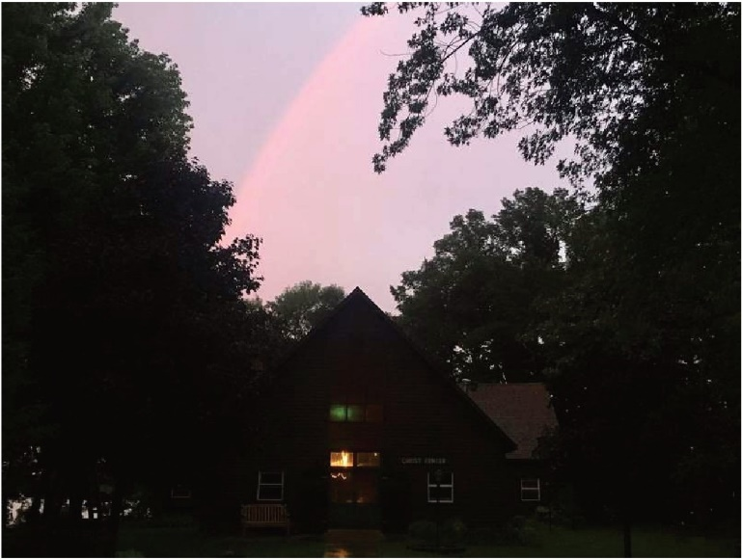
Participants stay in the Lakota Retreat Center, which also serves as the main "creation station" for the retreat and provides a relaxing and comfortable setting for the weekend. Lakota features lakeside views, cozy meeting spaces, and 17 sleeping rooms, each with a private bath. Linens provided.
Participants must follow SLM COVID-19 Policies and Pre-Screening. All registrations will have private rooms. Registration is limited.
Questions? Contact SLM @ (507)763-3567 or camp@shetek.org

