TLC Weekly: Sunday, January 16 to Sunday, January 23
Sunday, January 16 9am Worship
2 Epiphany 10am Coffee Fellowship
10:15am Education Hour
2pm “Celebration of Song” – Annual Community Event here at Tracy Lutheran
Monday, January 17 9am Lutheran Men in Mission Bible Study
11:30am Staff Meeting
Tuesday, January 18 9am Prairie Conference Pastor’s Meeting @ Hope Lutheran, Minneota
Wednesday, January 19 9am Do-Day Ladies
6:30pm Chancel Choir
6:30pm Youth Group (gr. 7-12)
Thursday, January 20 7pm Prophecy Circle, Mary Christian hosts
Friday, January 21 8am Breakfast and Bible (10-12 gr.) @ Amy Munson’s
Sunday, January 23 9am Communion Worship
3 Epiphany 10am Coffee Fellowship
10:15am Education Hour

The Radio Broadcast (KMHL 1400AM – or – 101.7FM) for this Sunday is by Don and Eilene Stanek.

Please continue to Remember in Prayer:
Please…
We are happy to include people in our prayer list, but we must have their permission to be included. Many folks are very private about what is happening in their lives and we want to honor that.
Keith Kropp – Gale Kropp’s husband
John Springer – Joyce Osland’s brother, has cancer
Roger Kiihn – at Prairie View
Gary Retzlaff – Larry’s brother, continued battle with cancer
Shirley Alf – recently hospitalized in Tracy
Stan Scheck – Kari Landuyt’s brother-in-law

January Acolytes: Brody Byrne, Brooke Swenhaugen
January Communion Preparers: Larry and Marge Fischer
January Communion Servers: Missie Erbes, Kathy Filter, Melody Caron
Coffee Fellowship: Sunday, January 16 Ronnie and Carol Dahl
Sunday, January 23 Missie Erbes
Sunday, January 30 Carolyn Engelkes and Mary Smith
Scripture Readers: Sunday, January 16 Sara Torkelson
Sunday, January 23 Sandy Ludeman
Sunday, January 30 LuAnn Kern
Ushers: Sunday, January 16 Chris Kamrud, Ronnie Dahl, Wayne Anderson, Darrell Christian
Sunday, January 23 Mark Peterson, Jim Julien, Mike Carlson, Larry Retzlaff
Sunday, January 30 Bruce Lerohl, Greg Carlson, Tom Streifel, Matt Loftness
Sunday Counters: Sunday, January 16 Seth Schmidt
Sunday, January 23 Khyle Radke
Sunday, January 30 LuAnn Kern
Financial Update (as of Wednesday, January 12):
General $1,075
Building $240 Bills Paid this week: $7,604
Missions $31
Total $1,346

Annual Meeting – Sunday, January 30 at 10am
Tracy Lutheran’s Annual Meeting will take place on Sunday, January 30 at 10am following the morning worship service.

Annual Spaghetti Brunch and Pie Auction
Following our Annual Congregational Meeting on Sunday, January 30th you are invited to join us for our Annual Spaghetti Brunch and Pie Auction put on by the youth of our congregation. Look forward to fun and laughs at our pie auction!
If you have hamburger you would be willing to donate, please bring it to the church by Friday, January 28th.
Pastoral Home Visits
Pastor Eric is available to do a visit (for communion or prayer) in your home. Please call the church office (629-3563) if you would like to have him bring you communion or to stop by for a pastoral visit.

Drawing God
A kindergarten teacher was walking around observing her classroom of children while they were drawing pictures. As she got to one girl who was working diligently, she asked what the drawing was.
The girl replied,
“I'm drawing God.”
The teacher paused a moment and then said,
“But no one knows what God looks like.”
Without looking up from her drawing, the little girl replied,
“They will in a minute.”

Septic Committal
A new preacher was asked to hold a graveside committal service at a pauper's cemetery for an indigent man with no family or friends.
Not knowing where the cemetery was, he made several wrong turns and got lost. When he eventually arrived an hour late, the hearse was nowhere in sight, the backhoe was next to the open hole, and the workmen were sitting under a tree eating lunch.
The pastor walked over to the open grave and found the vault lid already in place. Feeling guilty because of his tardiness, he preached an impassioned and lengthy service – sending the deceased to the great beyond in style.
As he returned to his car, he overheard one of the workmen say to the other,
“I've been putting in septic tanks for twenty years… and I ain't never seen anything like that!”

Enjoy a crafting weekend at SLM! Spend time in a relaxed, Christ- centered environment crafting, bonding with others, delicious food, and daily devotions. Be inspired and sha re inspiration with others!
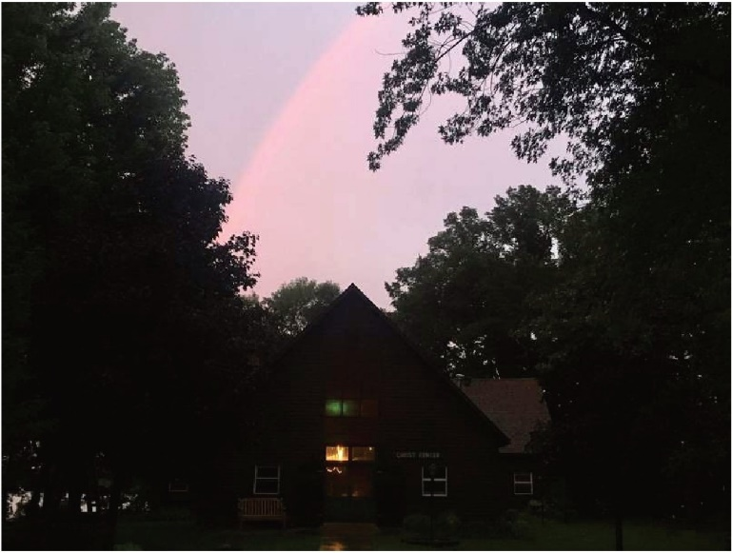
Participants stay in the Lakota Retreat Center, which also serves as the main "creation station" for the retreat and provides a relaxing and comfortable setting for the weekend. Lakota features lakeside views, cozy meeting spaces, and 17 sleeping rooms, each with a private bath. Linens provided.
Participants must follow SLM COVID-19 Policies and Pre-Screening. All registrations will have private rooms. Registration is limited.
Questions? Contact SLM @ (507)763-3567 or camp@shetek.org

